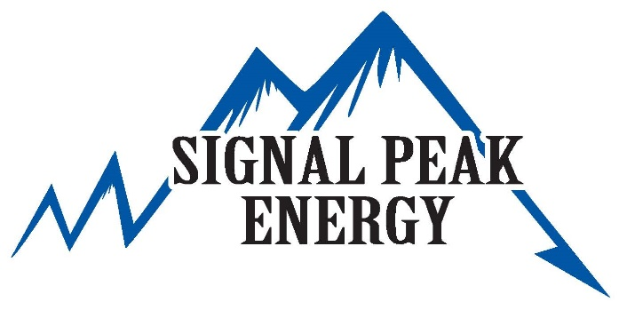
Signal Peak, through their Community Foundation, is pleased to offer scholarships for college bound students for the 2023-24 academic year. The scholarship is available to any resident of Musselshell County and is renewable.
Signal Peak Energy Scholarship

The scholarships will be offered in three different tier levels based on academic major. The tiers are as follows:
Tier 2: Trade Schools
Up to $5,000
Welding
Diesel/Automotive
HVAC
Electricians
Plumber
Tier 3: Other
Up to $1,000
Undeclared
Any Other Major

Tier 1: Engineering
Up to $10,000
Mining Engineering
Electrical Engineering
Geological Engineering
Metallurgical Engineering
Renewal Criteria:
If you have previously received a scholarship from the Signal Peak Community Foundation, you are eligible for renewal for the next academic year if you meet the following criteria:
- Will be registered as a full-time student (>12 credit hours)
- Maintained a cumulative GPA >3.00
- Have maintained the same Tier status that the original scholarship was granted under

If applying for a new or renewal scholarship for the 2023-24 academic year, please complete the form on the following page by March 31st, 2023 and return to the following:
Signal Peak Community Foundation
c/o Sue Olson
1230 Fattig Creek Road
Roundup, MT 59072

Signal Peak Energy also encourages all high school and college students to consider us for their full-time, part-time, and seasonal employment needs.
Signal Peak, through their Community Foundation, is pleased to offer scholarships for college bound students for the 2023-24 academic year. The scholarship is available to any resident of Musselshell County and is renewable.
Signal Peak Energy Scholarship Application Form

Instructions:
- Please complete this form electronically. Make sure all relevant information is provided.
- Attach this form with the following information, in sequential order.

New Student Application
  - One-Page Resume
  - Two Letters of Reference
  - Current Academic Transcript
  - 1-2 Paragraph Essay Answers
    - What does energy independence mean to you and how will your career influence this issue?
    - How has growing up in a rural community shaped your post-graduation plans?
Renewal Application
- One-Page Resume
- Current Academic Transcript
- Written Academic Update
  - 1-2 paragraphs
  - Description of Courses
  - Description of Future Work Plans

Renewal Application
New Student Application
Personal Information: |  |  |  |  | Please Choose: |  | ☐ ☐
Applicant Name:
Address:
City: |  |  |  |  |  |  |  | State: |  |  |  |  | Zip:
Contact Phone: |  |  | No |  |  |  |  | E-mail:  Yes
Are you related to any current Signal Peak Employee? |  |  |  |  |  | ☐ ☐ |  |  | If so, who?

Academic Information:
High School Attended: |  |  |  |  | College:
GPA: |  |  |  |  | Major:
Class Rank: |  |  |  |  | Minors, If Applicable:
 |  |  |  |  | GPA: | No  Yes
 |  |  |  |  | Full-time Student: |  |  |  | ☐ ☐  Tier 3  Tier 2  Tier 1
Which Tier will you be eligible for in the upcoming academic year? |  |  |  |  |  |  |  |  | ☐ ☐ ☐

Community Foundation Use Only:
Foundation Representative Signature:
Scholarship Amount Awarded: |  |  | Date:

